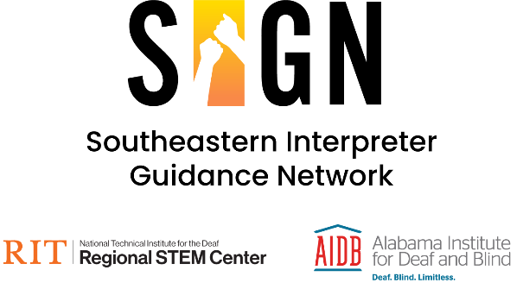

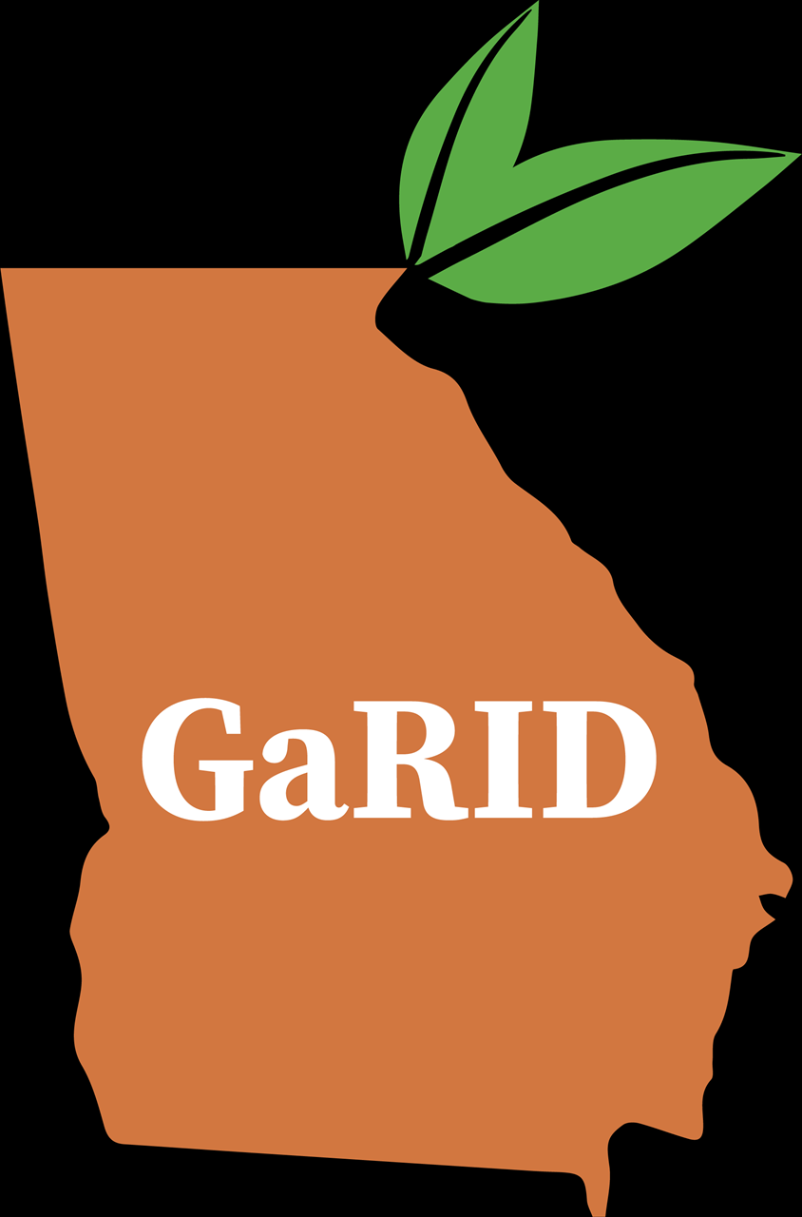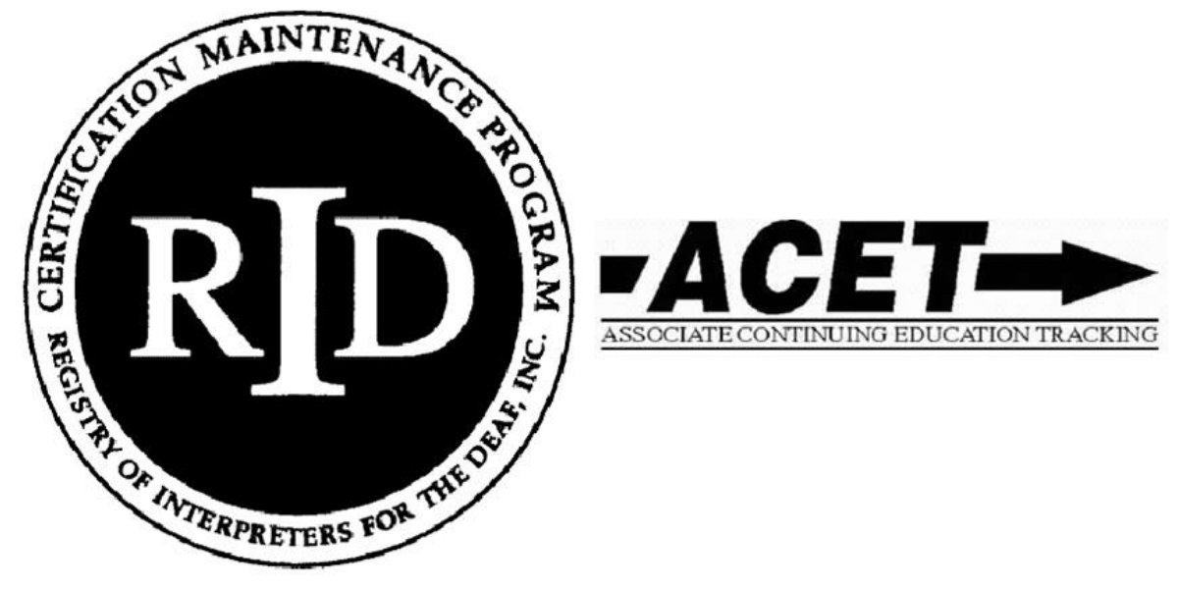

Legal Interpreter Training Series

Save the Dates!

[ASL Version](https://youtu.be/luc5SUyYD3k)

Are you an interpreter currently working in community and/or legal settings?

Do you want training to improve your current work and learn more about legal settings in community work and how they impact courtroom interpretation?

Are you curious how different interpreting settings impact others and how they impact one another in legal interpreting?

If you answered yes to any of these questions, then the SIGN Legal Interpreter Training Series may be for you!

**What is the SIGN Legal Interpreter Training Series?**

The Southeastern Interpreter Guidance Network (SIGN) along with a team of interpreters who specialize in legal interpreting, members of the community, and professionals from a variety of settings will provide training on the following topics:

1. Interpreting for families who are involved in the juvenile system
2. Interpreting for law enforcement from first contact to the booking system
3. Interpreting depositions
4. Interpreting in the courtroom

This innovative approach will enable interpreters to gain a greater understanding of the various systems and their role within them. In addition, interpreters will be able to network with their peers from across the southeastern region of the country.

Training will include theory as well as practical application of skills learned. In addition, interpreters will be able to increase their knowledge and experience of working within a HI/DI team.

Participation is open to anyinterpreter who meets the minimum criteria outlined below. Applications are being accepted to ensure that the participants include individuals with diverse backgrounds. Deaf Interpreters who are not yet certified, but are currently working in their communities with a goal of certification are *strongly encouraged* to apply.

Additional information about SIGN can be found [here](https://www.aidb.org/Page/4084).

**About the training:**

On site:

Each session is 3 days in length (Friday - Sunday) and will be taught by an experienced CHI/CDI team in tandem with professionals who work in the settings listed above.

Schedule:

February 23 - 25, 2024: Interpreting for families who are involved in the juvenile system

April 19 - 21, 2024: Interpreting for law enforcement from first contact to the booking system

June 21 - 23, 2024: Interpreting depositions

August 16 - 18, 2024: Interpreting in the courtroom

Online:

Training sessions are every other month beginning in February 2024 and ending in August 2024. During the off-site months, a brief online assignment will be required of participants. Each online assignment will require approximately 1-2 hours of the participants’ time.

**Attendance and participation in all on site sessions and online assignments is required.**

**Ready to apply for the SIGN Legal Interpreter Training?**

Applications are now open for participants to join this training which focuses on legal and community interpreting. Please note, *seating is limited to 20 participants*.

This application should take no longer than 15 minutes to complete.

**Application Deadline.**

The deadline for applications is Sunday, September 30, 2023 by 9 pm CST. No applications will be accepted after this time.

**Application Materials**

Before applying, please have the following information ready:

* Your training, education, interpreting experience, and 3 references.

**Application Review**

Each application will undergo anonymous review by a team of raters using predetermined selection criteria. Applicants for this training series will be screened based on the following minimum criteria and desirable characteristics:

**Minimum criteria**

* Currently reside in one of the following states: Alabama, Arkansas, Florida, Georgia, Kentucky, Louisiana, Mississippi, North Carolina, Oklahoma, South Carolina, Tennessee, and Texas
* 8 - 10 years of interpreting experience working in a variety of settings, with a variety of deaf people
* RID Certification. Deaf Interpreters who are not yet certified, but are currently working in their communities with a goal of certification are *strongly encouraged* to apply.
* Attendance at all 4 training sessions in Huntsvlle AL.

**Desired criteria:**

* Evidence of prior training (ex. ITP, workshops, mentoring, etc.)
* Evidence of experience working in a variety of community settings
* Evidence of commitment to participating in inclusive and effective training with interpreters and community trainers from a variety of backgrounds.
* Three professional references.

**Application Notification**

Applicants will receive notification of decision via email in early November 2023.

**Participant Expectations**

Participants are expected to create time and space in their schedule to fully engage in the on-site training program and submission of the online assignments. The on-site training requires a commitment of 3 days, once every two months beginning in February 2024 and ending in August 2024:

* February 23 - 25, 2024: Interpreting for families who are involved in the juvenile system
* April 19 - 2, 2024: Interpreting for law enforcement from first contact to the booking system
* June 21 - 23, 2024: Interpreting depositions
* August 16 - 18, 2024: Interpreting in the courtroom

Attendance at the initial training session will indicate that the participant is engaged and willing to attend all sessions unless some unforeseen emergency occurs that prevents their involvement.

Applicants for the program require access to a computer with the ability to record a video of yourself answering a question as well as submitting four, brief online assignments.

**Cost to participate**

***SIGN will cover all costs associated with this training other than travel.*** There is no cost to participants to apply for or attend any of the training sessions. Once accepted into the Legal Interpreter Training, you will be provided with your lodging and training location information.

**Are CEUs available?**

Yes, RID CEUs will be available. CEUs sponsored by Georgia RID. The onsite AND online components of the program must be successfully completed to be awarded CEUs. There is no cost for processing CEUs. **No partial CEUs will be awarded.**

**Further Questions about the training?**

Please email Deborah Makowski ([makowski.deborah@aidb.org](mailto:makowski.deborah@aidb.org))

[**Apply Here**](https://docs.google.com/forms/d/1irME0a7OZpa6mKELwEWBkgGxK7gnXTCgaAtyzXpQYJU/prefill)

**About SIGN**

The Southeastern Interpreter Guidance Network (SIGN) has been established to create a mentoring network across the southeast to support and empower interpreters at all stages of their career. SIGN is one of the outreach programs hosted by the Alabama Institute for Deaf and Blind (AIDB) Special Projects office through their partnership with the NTID Regional STEM Center. SIGN is based at the AIDB North Campus in Decatur, AL.

SIGN provides mentor training, resources, scholarships, and the opportunity to mentor and be mentored within and across 12-states including: Alabama, Arkansas, Florida, Georgia, Kentucky, Louisiana, Mississippi, North Carolina, Oklahoma, South Carolina, Tennessee, and Texas.

If you have any questions about SIGN or would like to learn more, please contact Deborah Makowski @ [sign-contact@aidb.org](mailto:sign-contact@aidb.org)